Content Management Portal (CMP) Project
Deployment Manual

Document Reference: |  | CMP/DOCS/TU.2/
Project: |  | Content Management Portal (CMP)
Document Title: |  | Deployment Manual
Version: |  | 1.0
Date: |  | 15 Jan 2009
Prepared/Revised by: |  | Ravi
Approved by :
 |  | Sui Haiyang |  | Date
 |  | Project Manager
 | © 2009  The information contained in this document is the property of ISS. The contents must not be copied in whole or in part for purposes other than which it has been supplied without the consent of ISS, or, if it has been furnished under contract to another party, as expressly authorised under that contract, then ISS shall not be liable for any errors or omissions. |  | 
Institute of Systems Science, 25 Heng Mui Keng Terrace,
Singapore 119615

Version History Record
Version | Date | Brief description of amendments and affected pages, paragraph
0.1 | 30/11/09 | Draft Issue
0.2 | 03/12/09 | Submission release
1.0 | 14/01/10 | Submission after review

Distribution:

Name | Department | Organisation
ISS Audit | ISS | ISS
Sui Haiyang | Project Manager | ISS-SE16S07
Gao Jia Si Karen | Quality Manager | ISS-SE16S07
Yap Sie Kuok, Thomas | Testing Manager | ISS-SE16S07
May Ann Sallan | Database Designer | ISS-SE16S07
Rajendran Kumaraguru | System Architect | ISS-SE16S07
Thiyagarajan Ravikumar | Technical Lead | ISS-SE16S07

Table of Contents
1. Software Installation & Checking Procedure 2
Software Deployment Checklist 2
Interface Application 2
2. IIS Configurations 4
3. Configuration 9

Software Installation & Checking Procedure

Software Deployment Checklist
- Windows Server 2008 R2
- MS SQL Server 2005
- IIS 7.0
- .Net 3.5
- Microsoft Office 2003

Interface Application
Interface application Deployment File will follow the below structure,
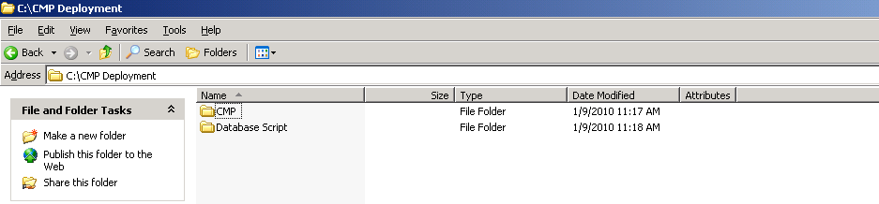

Folder Name | Folder Location | Description
DatabaseScript | C:\Database Script | All the Database Script related to the Content Management are located here.
CMP | C:\CMP | Copy the whole CMP folder to the <C drive>

Run Database script Sample, Pl. proceed in the same sequence in the “CMPCreationScript_V1.0.sql” file,
Double click the script from the DB Server,
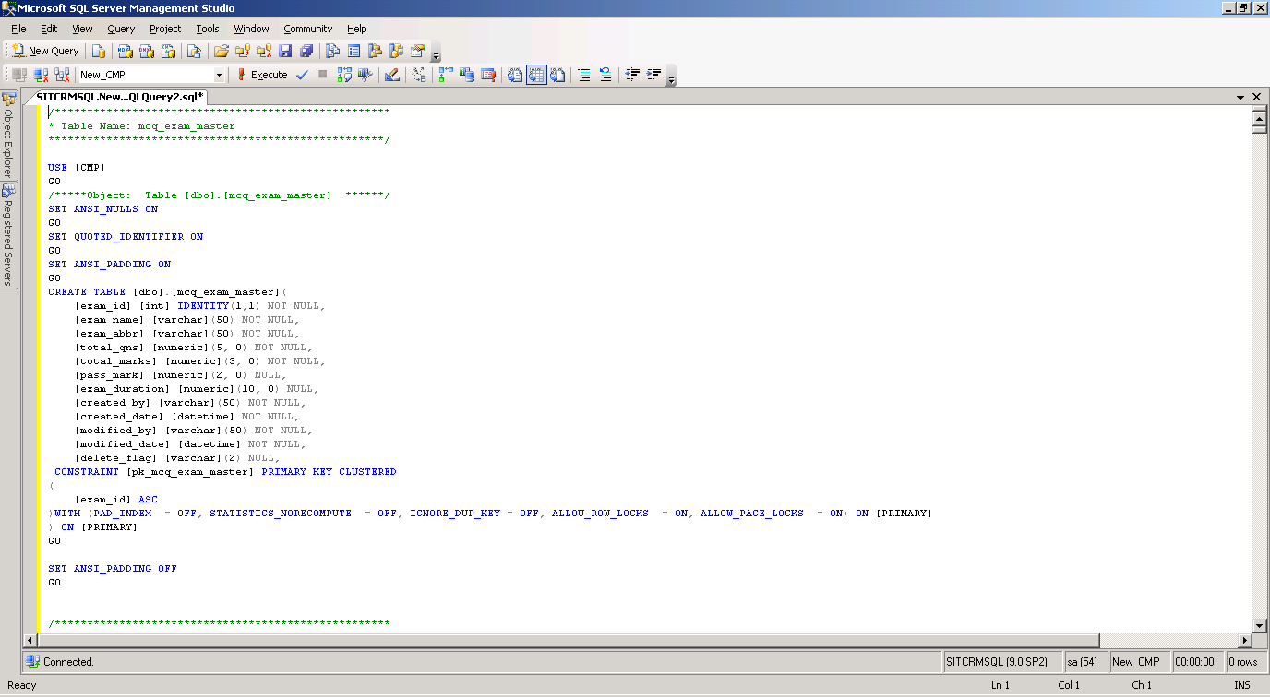
Click the Execute button to run the scripts.
Note: Use the account which has Database Creation Permission.

IIS Configurations
- Right click Site → select “Add Web Site”
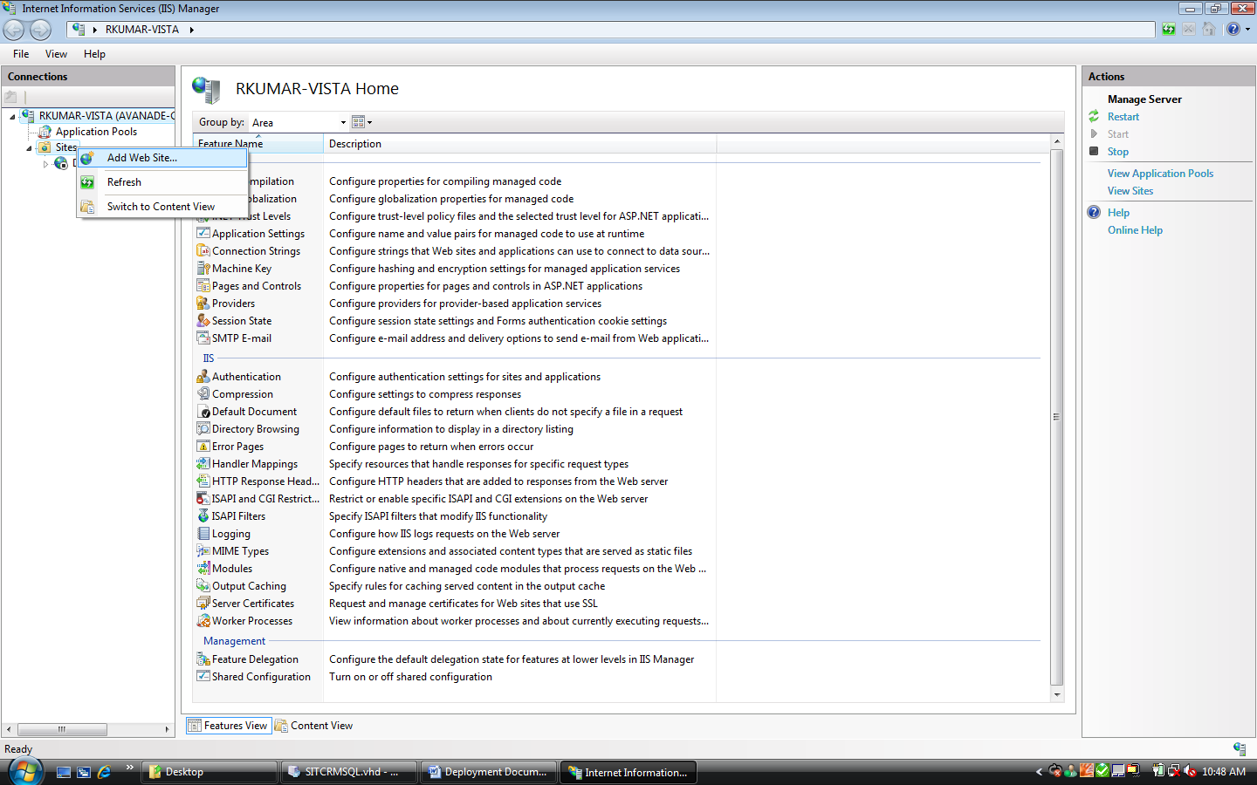
- Enter “ContentManagement” in Site Name and give the physical path as “C:\inetpub\wwwroot”. Then click “OK”
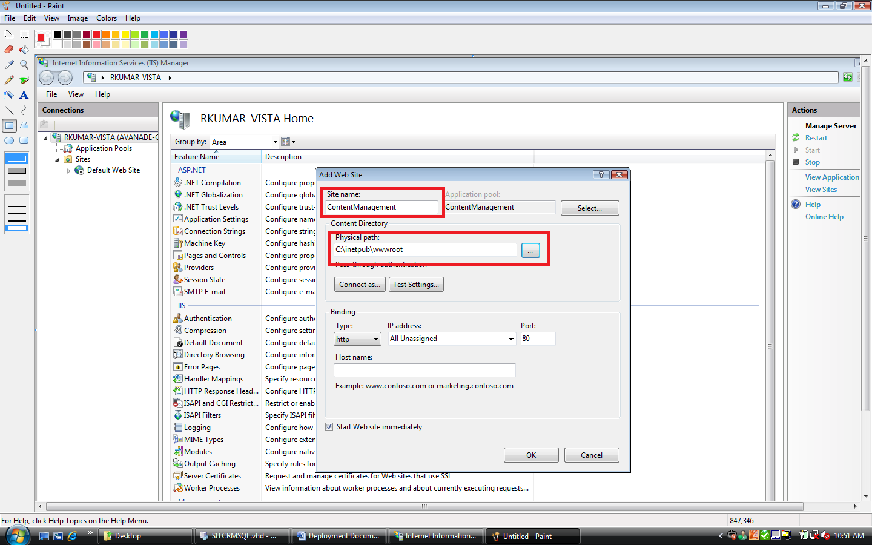
- Right click “ContentManagement” → select “Add Virtual Directory”
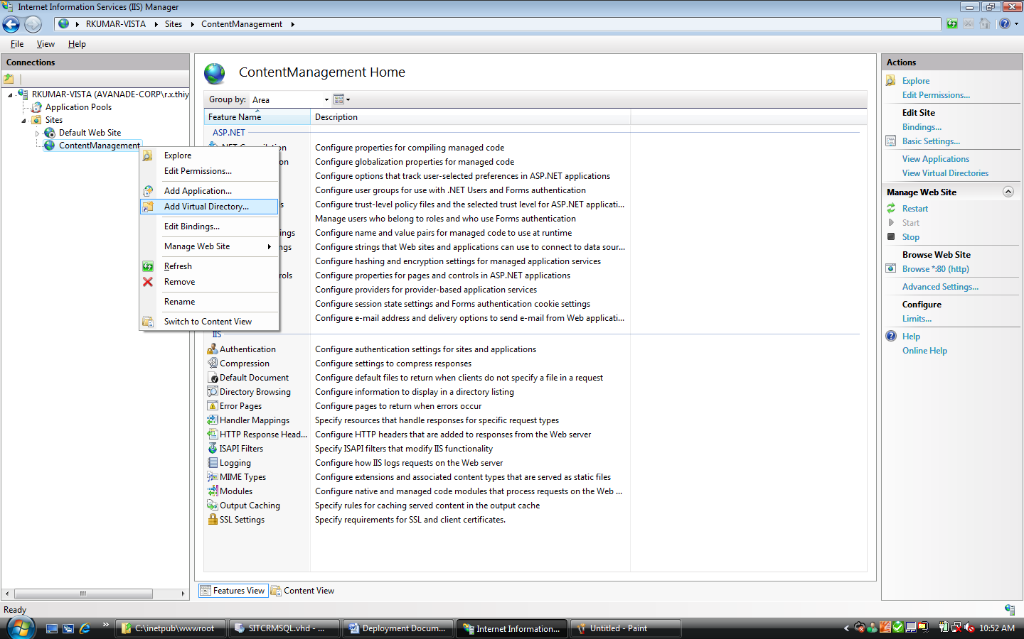
- Enter “CMP” in Alias and enter the physical path of the files you have copied “C:\CMP”. Then click “OK”.
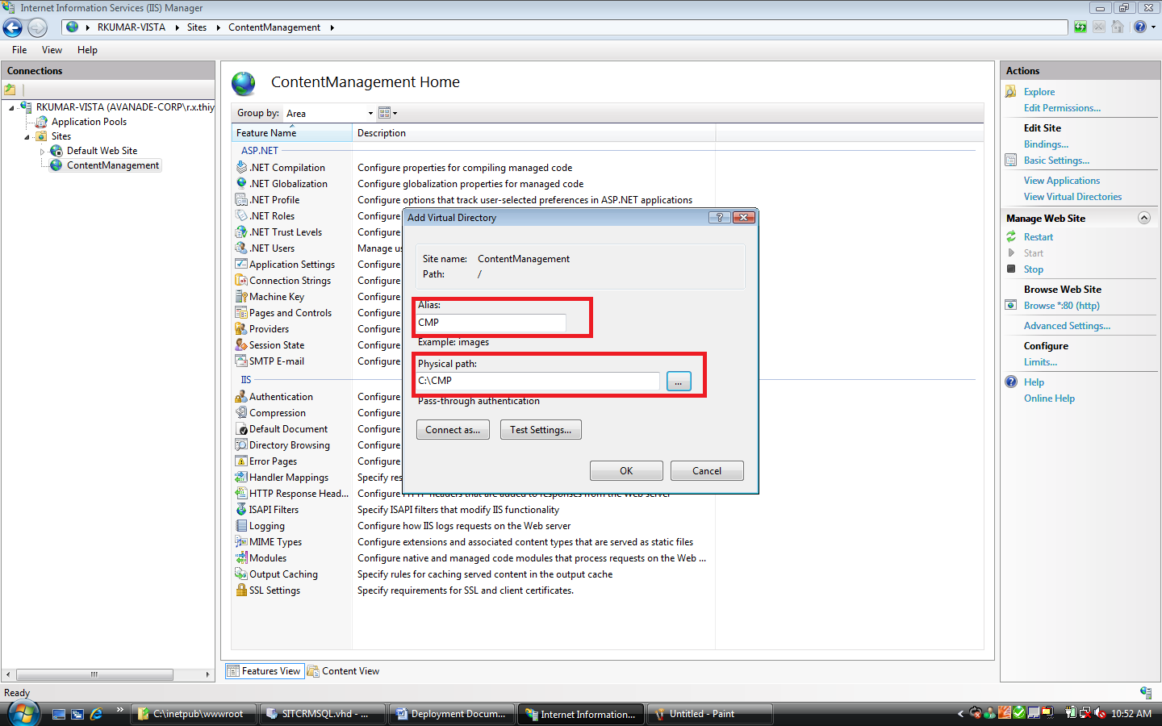
- Right click “CMP” → select “Convert to Application”
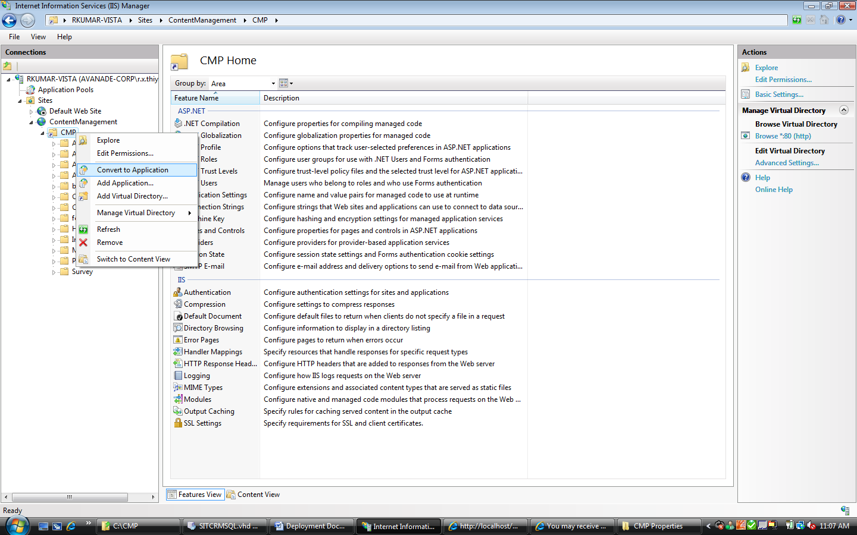
- Click “OK”
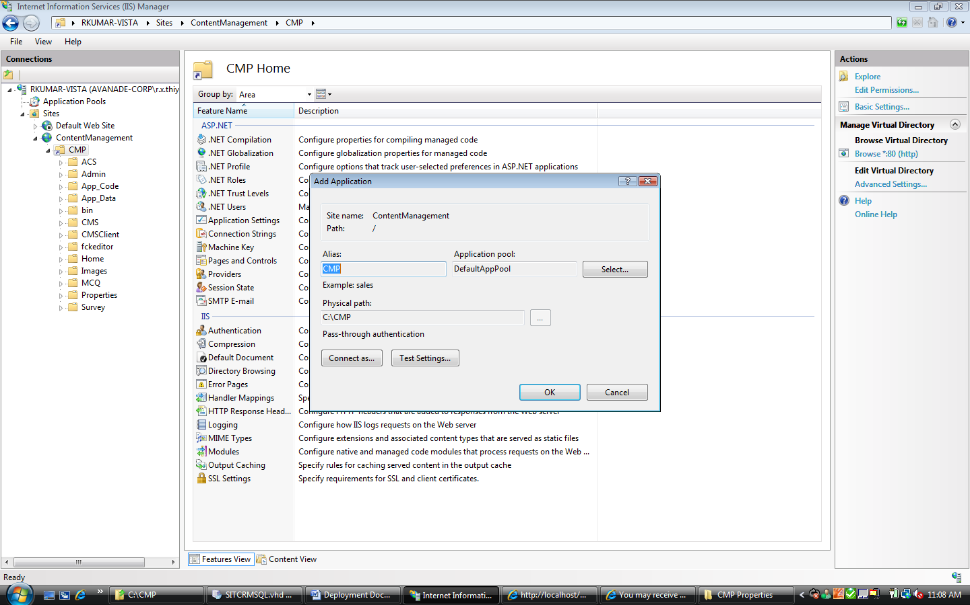
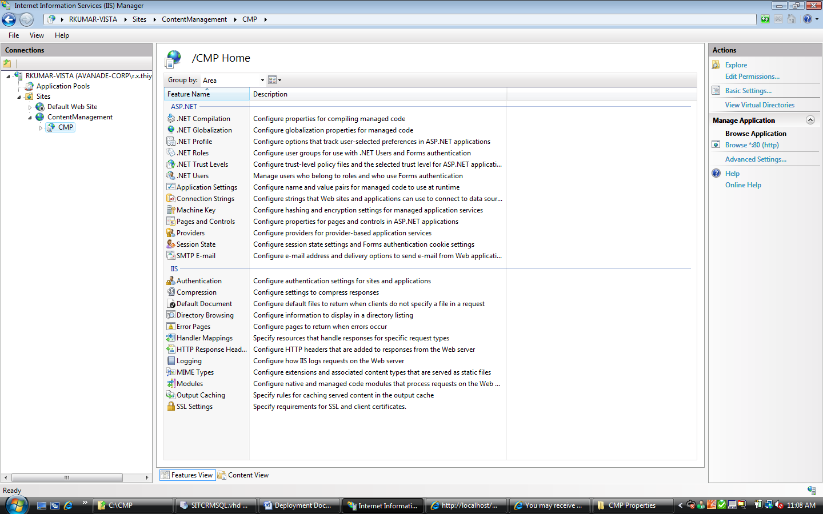

Configuration
- Open “C:\CMP\Web.config” in Notepad or Wordpad
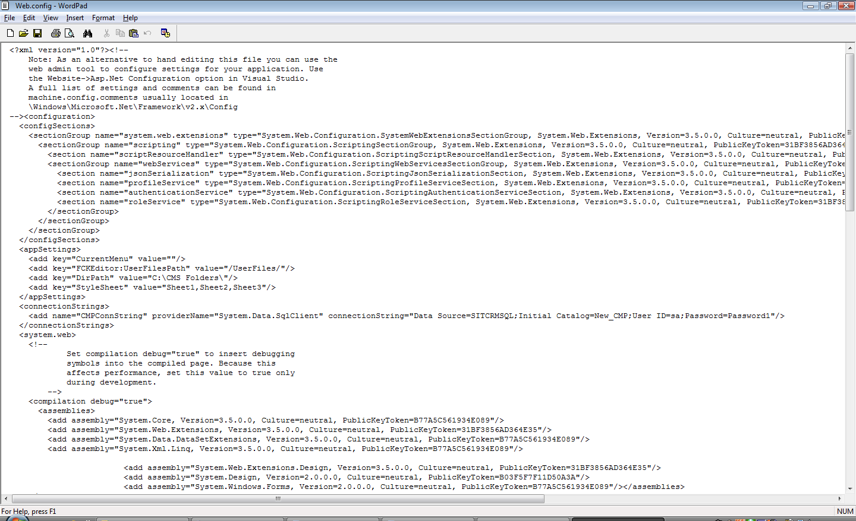
- Search for “CMPConnString”
- Change the connection string to your Database configuration “server=haiyangs\sql2005;uid=sa;pwd=Sa001;database=CMP;Pooling=false;Connect Timeout=30”

Approval Record DOCS/Forms/Approval
Project Name Content Management Portal
Document Ref CMP/DOCS/TU.2/
Approved by Haiyang | Date
Authorised by Haiyang | Date
The document authorisation appears on the title page. |  | ✔
The structure of the document is logical. |  | ✔
The distribution list is correct. |  | ✔
The title page is signed |  | ✔
Calculations appear reasonable, are neatly presented and have been checked. |  | ✔
Theory and formulae are correct and properly applied. |  | ✔
Illustrations are relevant, readable and logically placed. |  | ✔
There are no typographical errors. |  | ✔
Units are consistent throughout. |  | ✔
The security classification is correct. |  | ✔
There are no obvious omissions. |  | ✔
The document complies with the Client's requirements, however specified. |  | ✔
Responsibility is accepted for all opinions, conclusions and recommendations. |  | ✔
The document does not run counter to company policy. |  | ✔

